Optimized Navigation using Deep Learning Technique for Automatic Guided Vehicle

Anubha Parashar¹, Apoorva Parashar², Mamta Mittal³

¹Department of CSE, Manipal University Jaipur, Rajasthan, India

²Department of CSE, Maharshi Dayanand University, Rohtak, India

³ Department of CSE, G. B. Pant Government Engineering College, New Delhi, India

*Corresponding author: mittalmamta79@gmail.com

Abstract
Autonomous driving has passed the point of being called the biggest step, as the smart car revolution is already taking shape around the world. Self-driving cars are relevant if not prevalent and the biggest obstacles to reach the mass adoption are customer acceptance, cost, infrastructure and the reliance on several onerous algorithms that include perception, lane marking detection, path planning and variation in pathways. This study tackled the mentioned problems with a straightforward and cost-effective solution, using end to end learning and replacing the numerous sensors with a camera and commandeering just the forward, backward, left, and right controls. In this research, authors have used most popular method of deep learning i.e. Convolution Neural Network (CNN) to train the collected data on the VGG16 model. Later these have optimized directly by the proposed system with cropping each unnecessary image and mapping pixels from a single front-facing camera to direct steering instructions. It has been observed from the experimental work that proposed model has given better result than the existing work i.e. increase in the accuracy from 88% (Udacity training dataset) to 98% (proposed). This model is suitable for industrial use and robust in real time scenarios therefore can be applied in modern industrialized systems.

Keywords: Smart Car, Deep Learning, CNN, Internet of Things, Computer Vision

- Introduction

A smart car is generally made of two controlling units that dictate its actions, controller of low magnitude and high magnitude. Controller of high magnitude takes input from its components i.e. the driver (in this case the camera), its surroundings such as the traffic and the sensors in place, it then after deducing the correct actions to be taken sends signals to the low-level controller that controls the brakes, steering, engine and throttle [1]. To do this successfully it needs to understand driver psychology, how and when a specific maneuver is necessary, which changes with the terrain and the area the car drives in since driver temperament and driving style cannot be universally generalized [2]. It is also difficult for cars relying on so many sensors to be able to adapt to new surroundings and to reconfigure the system to achieve a different goal based on learning that occurs on the move, especially when noisy sensor data is received [3]. To understand and correctly predict such outcomes is precarious. Studies show that if the driver is given even a half a second extra before a collision, 60% of accidents can be avoided and this percentage increases to 90% if one second of warning time can be provided [4]. Such results stress the importance of timely and correct decisions that face problems with the conventional architecture of a smart car system.

One of the breakthroughs in navigating autonomous vehicles happened because of using CNN [5 – 13]. In order to navigate the vehicle with complete safety of passengers, The Convolutional Neural Network model is deployed and is trained as well as tested. The CNN model maps the complete driving model in real time by collecting information about driving behavior and taking images from the angle of steering wheel and camera [14 – 21]. Vehicle performance is heavily dependent on the dataset, i.e. if the vehicle encounters a new hazardous situation (one that the model is not trained upon) occurs, the system will not give a good analysis and an accident might happen. There are a lot of causes for the system to malfunction and crash- failure of software, or the camera sensor impairment.

The rest of the chapter follows the following pattern. In Literature study, authors have explored the ultra-modern models used for self-driving vehicles. A plethora of research has been done and it has been studied carefully with more precision to find out the limitations of conventional Deep Neural Network (DNN) based models. In section three optimization technique has been proposed which uses the CNN architecture for autonomous driving. In order to validate this methodology, we split the training data (training is done on Udacity generated training data) and it is tested with the real time data; presented in section four. At last conclusion and future work has been presented.

Literature Review
Lately, computer vision is being used in autonomous vision for steering the vehicle [22]. But computer vision alone is insufficient to provide completely accurate results so, it is being used along with sensors like radars, LIDAR, and object detection [23]. These sensors are then fused within a Kalman filter with the help of models. Our model is based on neural networks, has a monocular camera which is used by the detector to abstract single frames and the built system does not use any temporal features. Model has trained the network to project the depth based on labels taken from return of the radar. This network mostly learns from the annotations even though it has the information about the model and depth of the road [24].
This journey to make a Smart Autonomous vehicle began with the invention of modern cruise control in 1948 [25]. Many dedicated steps have been taken in this direction to make self-driven cars a reality. Self-sufficient Land automobile in Neural Network (NN) diversified the field by combining End to End learning with a NN for solving any issue. Defense Advanced Research Projects Agency (DARPA) then gave perspective to what can be achieved with the technical know-how of the time [26]. In the recent past when CNN was trained for mapping camera pixels so they could be interpreted directly into guiding orders [27], it demonstrated the reliability of this approach in contrast to the more modular alternatives [28]. One of the most used techniques for self-driving vehicles consists of DNN. A lot of companies that sells car like Ford, Tesla, BMW and Volvo swear by using DNN. A lot of Software firms such as Uber, Lyft and Google are also deploying DNNs in their autonomous vehicles [29]. The working of such systems is based upon the acute transfer of information from Radar, Cameras and LIDAR as an input to the Deep Neural Network like Recurrent Neural Network (RNN) or CNN [30].
The information is processed by the system in order to control the angle of steering wheel and the velocity of the vehicle being driven. For instance, the models used by Udacity make the use of both the RNN and CNN based technique whereas, the models created by NVEDIA, makes the use of only a CNN model for processing the input data provided in order to take the command of the steering wheel [31]. A DNN based system can sometimes misread the given data and cause treacherous consequences [32]. A plethora of studies has been done on the DNN based models and it is found that these systems are vulnerable to erroneous data and can malfunction easily [33]. For instance, they can exploit a DNN based system by adding a small disruption in the image so that the system categorizes into a different group [34].

Even the objects can be morphed physically by the attackers for causing a glitch in the self-driving system based on DNN [35]. These low-cost techniques used by the attackers can cause inaccuracy in measuring distances, resolution and angles. Likewise, barricades or lumber present on the road can also lead the system to produce incorrect outputs [36]. The foundation of the end to end approach was laid almost 14 years ago in an effort by DARPA-autonomous-vehicle (DAVE) [37] where an autonomous car ran along an alley filled with junk. [38]. It demonstrated that this approach was viable and adequate for the functioning of a smart car. The end to end approach thus provided alternatives which were uncomplicated and easier to test [39].

With the advancement in technology, the study achieved similar functionality more skillfully and with limited resources. At the center of this end to end learning is the CNN, the driver’s actions are based upon the training. The data was not hard to collect which made it possible to do rigorous experimentation as the system itself could be reproduced efficiently at a low cost. The data of a system could also be shared with another of the same kind to improve performance. Autonomous driving technology is a fast-advancing field which has prompted a lot of questions. Some of these queries are related with the operational models suitable to the vehicles in figure 1. One of the key viable determinants of the model is hustling of the cost structures.

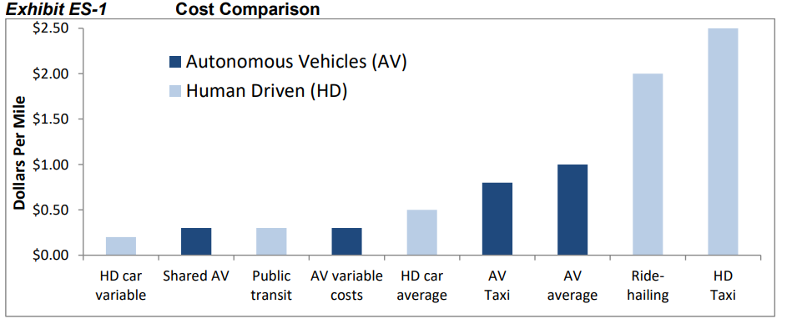
Figure 1: Cost Comparison of Autonomous and Human Driven Vehicles

With the help of an extensive study of cost structures, we found that public transport will remain competitive (economically) as the demands are high for large vehicles in order to transport goods. For instance, in densely populated metropolitan areas, public transport is cheap as compared to private, pooled or autonomous cars. And in the regions where public transport is unavailable, people tend to choose pooled vehicles.

Proposed Methodology

Previous methodologies discussed in literature were based on the pretrained DNN networks, but in this study an optimized navigation model has been proposed which helps the Automatic guided Vehicle more accurately with the combination of deep learning pipeline and setting the parameters of CNN network optimally.

In step one, authors have used a toy car and mounted a raspberry pi on top of it. An 8 MP camera has inserted in the raspberry pi and is attached in a way that it got a clear view of the road ahead. In step two an ultrasonic sensor is attached on the bonnet of the car for detecting any obstructions on the road in figure 2.
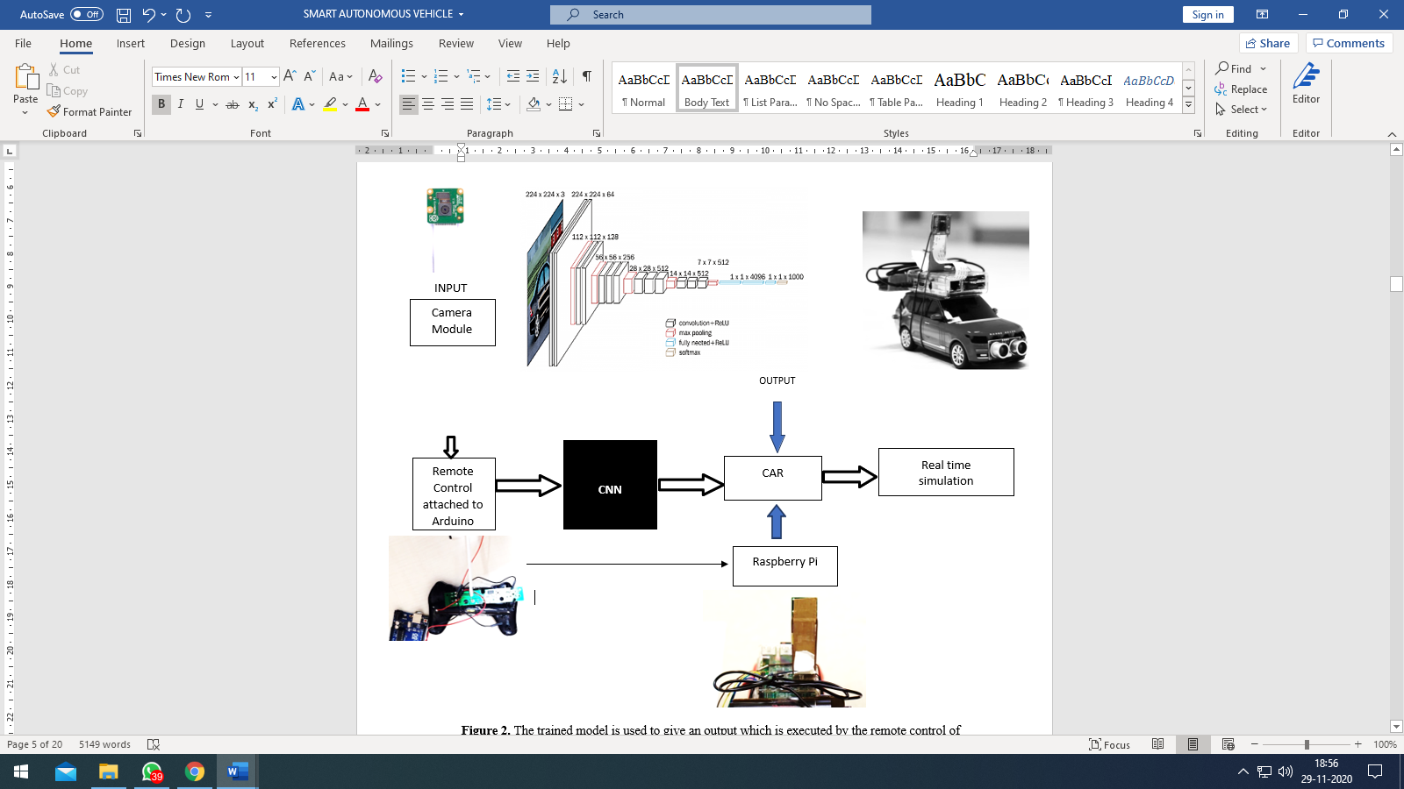
Figure 2. Trained Automatic Guided System controlled by the remote system

In step 3 the car can be driven by a remote control (the one that came along with the toy car) or could be driven autonomously (by applying Deep Neural Networks). In step four, use Arduino Uno to collect the data from remote (the data here is input for Arduino) has been done.

In step five, Wi-Fi module has been used, and it is latched on the Arduino in order to connect it to the inbuilt Wi-Fi of the raspberry pi. This way the raspberry pi has the access to the data coming from the remote control (data from Arduino through Wi-Fi), ultrasonic sensor (for detecting any road lumber) and input data of the road (from camera mounted on raspberry pi).

In step six, path is formed with black sheet of paper and details are painted on it. Some barricades and debris used to create obstruction. The model is trained on various road maps- straight path, curved left, curved right and circular. In step seven, testing is also done in phases. After completion, the model is given a final test curve with a broad curvature.

Data collection
Initially for testing the equipment and the plan of action, Stimulator for autonomous car by Udacity generated training data. It gives the user the liberty to drive a car on select pre-set tracks and the data is collected frame by frame that will be corresponding to how you drive. The data also contains steering angle and acceleration on each frame. This data helped actualize the direction of this study and formulate what kind of data the project needs so that it could be mapped onto directions. Thus, it had to be generated independently and specific to the need of the project. This is because of two major reasons, first that the RC car is not taking directions in the form of steering angle but only left and right. The second is that the camera angle played an important role in how the car understood the road ahead which greatly affected its decision-making capabilities.

Data collection of the next set is done by dispatching direction commands to car’s remote via the laptop which has transmitted to the car by the remote in figure 3. The camera view is visible on the screen of a remote device using the VNC viewer to stream the Camera’s Input. The car is steered on self- laid tracks of different orientations that is similar but not the same to which the car had to be tested on. It mimicked unmarked roads and the environment where it will be tested, the car had to stop, turn and avoid a collision.
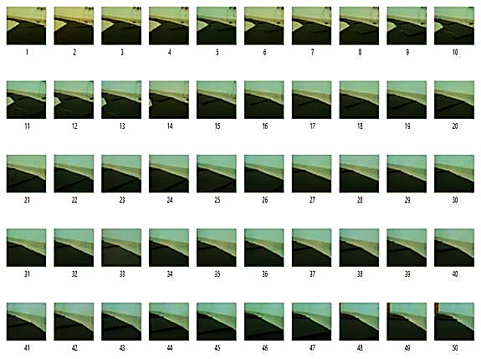
Figure 3: Sample section of the collected dataset.
The frames have captured with the help of the pi camera staged on a RC vehicle and it also documented directions at every moment which also time- synchronized as well embedded in the final data set. And this is repeated on diverse tracks until enough data that could be useful is collected. Thus, the data set had frames containing the tracks as viewed by the pi camera along with the directions.

Preprocessing Steps
In each image unnecessary data is cropped out i.e. reduced the height of the images in order to increase the contributing information in the frame and the images are resized so that less memory gets occupied. The images are then converted into YUV color-space as it allows systematic decrease in the quantity of necessary information to constitute images of equivalent quality. To increase the sample data, images containing turns are flipped with the corresponding directions.
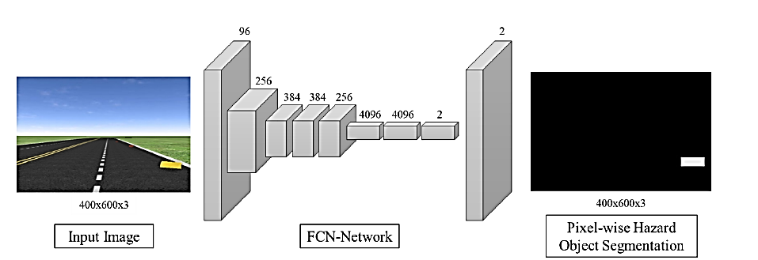
Figure 4: Feature extraction model using object detection and segmentation
The brightness of undecided frames is increased to random degrees which are to account for the change in lighting conditions and the same procedure is followed to reduce the brightness of random images in order to make the model more robust. Furthermore, Gaussian blur is applied to each frame for smoothing the image and to reduce noise in the captured frame.

Classification
The CNN is trained with the collected data and used VGG16 model, it has 16 layers and uses soft- max function as the classification layer as shown in figure 5.
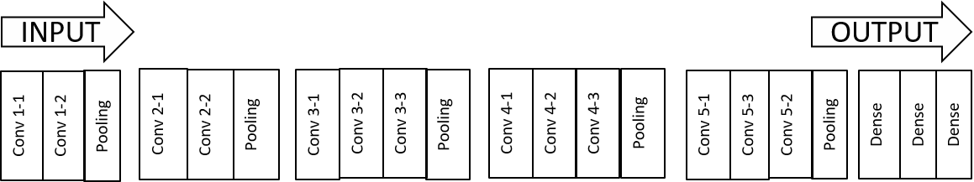

Figure 5: CNN Model Architecture
In order to train the system quickly, training is done on Udacity generated training data and tested with the real time data. For training CNN model is used and ReLU is used as activation function and softmax function is used to get the desired output.

When the autonomous vehicle turns left or right then we get a curve from training dataset to which shows the curvature of steering wheel, shown in figure 6.
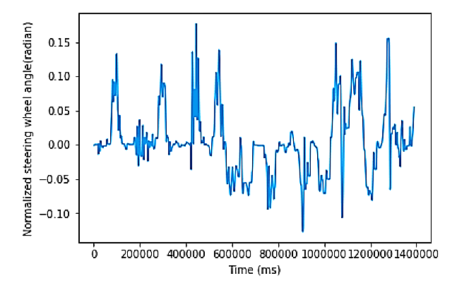
Figure 6: Normalization curve from training dataset to capture the curvature of steering wheel
Also, it is observed that unfairly large amount of the recorded data is corresponded to the car driving in a straight direction as compared to that of recorded while taking right or left turn, thus the data had to be normalized to avoid the possibility of a biased model and so that the scales could be made even.

Result Analysis and Discussion

This section has divided into three subsections, first section presents the experimental setup, in the second section detailed result analysis has been presented and third section discusses the approach with their detailed comparison.

Experimental Setup
Camera (as an input component): Model B+ board of Raspberry Pi that draws its power from an external power bank, attached with a Pi camera is used to collect input data. The camera is fitted on top of the car in such a way that it provided vision to the car and is overlooking the road and immediate surroundings. The client program runs on Raspberry Pi for sending frames to the Neural Network which is also stored in the pi.
Processing unit (Raspberry Pi): A computer’s PU manages numerous chores: input of data, training of NN and projection of data via commands and sending the resultant commands to the remote control for the final movement.
Unit of Autonomous vehicle control: Controller of the car used contains a switch for turning it on and. A Raspberry Pi is used to simulate button-press actions by soldering the jumper cables to the remote and then connecting them to Four GPIO pins which were selected for collecting pin chips of the remote, communicating to actions like left, ahead, right and back. When GPIO emits a low-signal, it means that the pins have been given supply from ground; whereas high-signal denotes chip resistance has no effect on the ground. Model returns the resultant commands to the pi using the serial interface, the Pi then outputs the signal to high or low after reading the input command, mimicking to drive autonomous vehicle by pressing buttons.
The model is trained on various road maps- straight path, curved left, curved right and circular. Testing is also done in phases. After completion, the model is given a final test curve with a broad curvature in figure 7 (a) and (b).
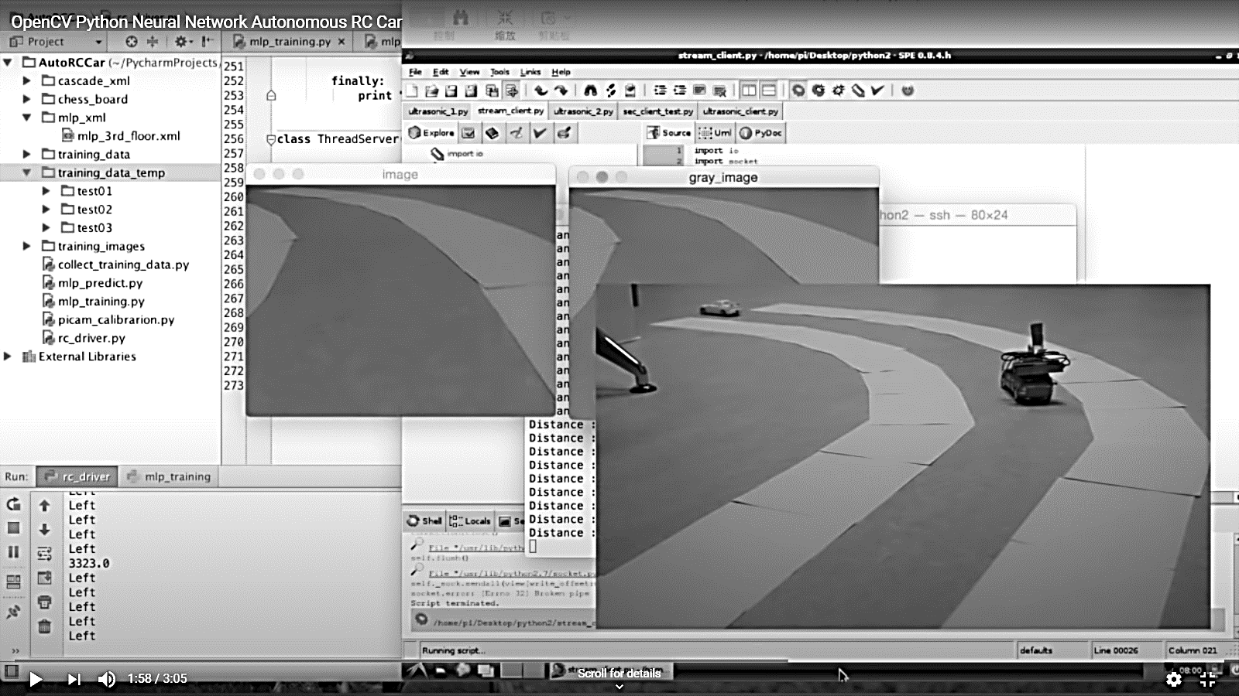
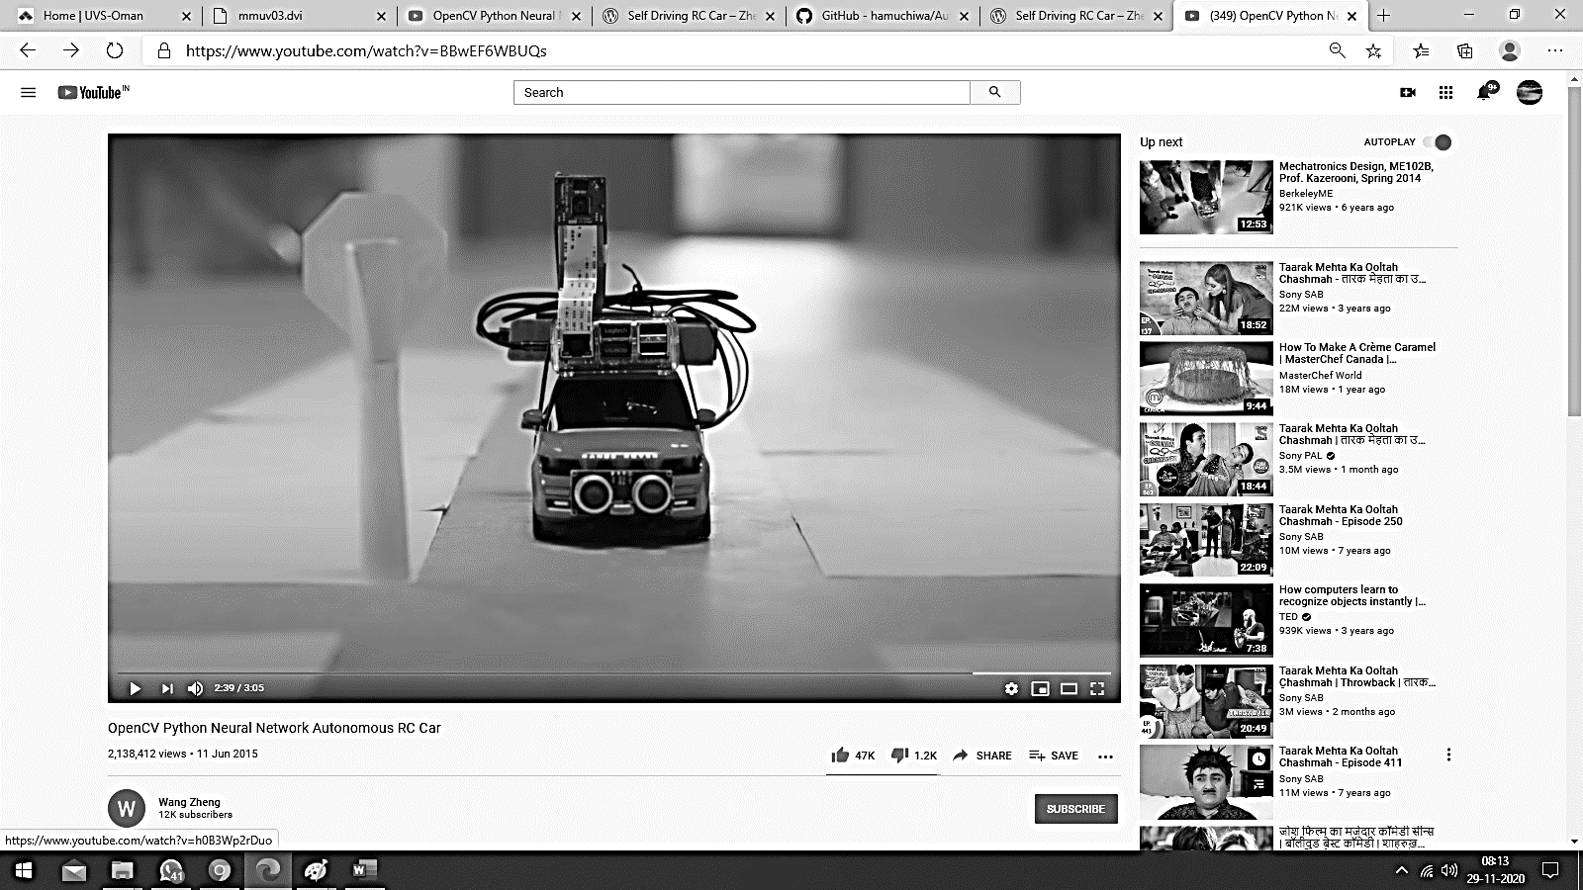

Figure 7 (a) Model training on various road maps- straight path, curved left, curved right and circular
(b) Car unable to detect road on right hand side, so taking a left turn

Arduino Uno is also used in this experiment to collect the data from remote (the data here is input for Arduino) in figure 8. A Wi-Fi module is also latched on the Arduino in order to connect it to the inbuilt Wi-Fi of the raspberry pi. This way the raspberry pi has the access to the data coming from the remote control (data from Arduino through Wi-Fi), ultrasonic sensor (for detecting any road lumber) and input data of the road (from camera mounted on raspberry pi).
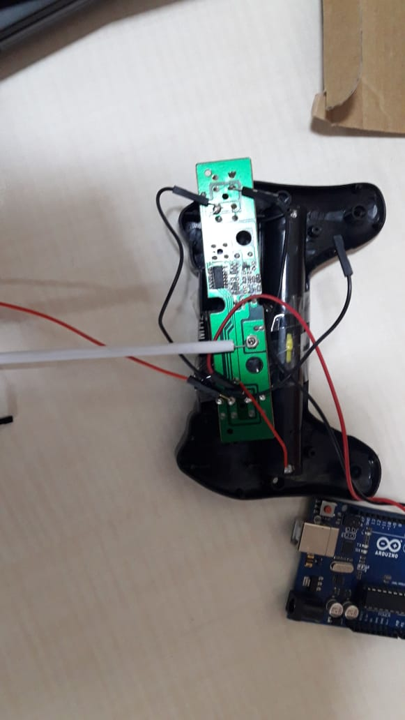
Figure 8: IR based designed remote control to collect the data from remote
Before testing the hardware on the actual field, the working of the model and the systems in place were to be tested. To achieve this, a video is fed to the training model frame by frame corresponding to which directions were generated by the CNN. After obtaining these results it is apparent that the basic functionality is to the point which is also confirmed by the accuracy graph shown in figure 9, results as given by the CNN for every frame.
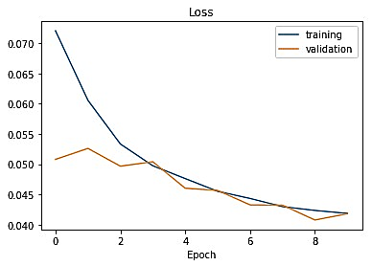
Figure 9: Shows training data and validation data
But due to the hardware restrictions i.e. having only left, right, forward and backward controls any concrete conclusions could not be drawn from this effort and field test is the only way to be able to understand the working and the shortcomings at length.

Result analysis
After rigorous test runs on tracks apart from which the car is trained on, it is concluded that the car can function competently in a controlled environment. The neural network is also working fittingly and gave better results than those obtained by previous studies as shown in Table 1.
Table 1: A comparison of the Accuracy of the current study with that of the others
 | Title of Paper | Accuracy
Muller, U (2006) | Off-Road Obstacle Avoidance through End-to-End Learning | 75%
Mori,K (2019) | Visual Explanation by Attention Branch Network for End-to-end Learning-based Self-driving | 79%
Xu, H (2017) | End-to-end Learning of Driving Models from Large- scale Video Datasets | 84.6%
Bojarski, M (2016) | End to End Learning for Self-Driving Cars | 88%
Proposed Method | Smart Autonomous Vehicle using End to End Learning | 98%
The only complications faced were pertaining to the type of car used, which is later assessed could be comfortably resolved in figure 10.
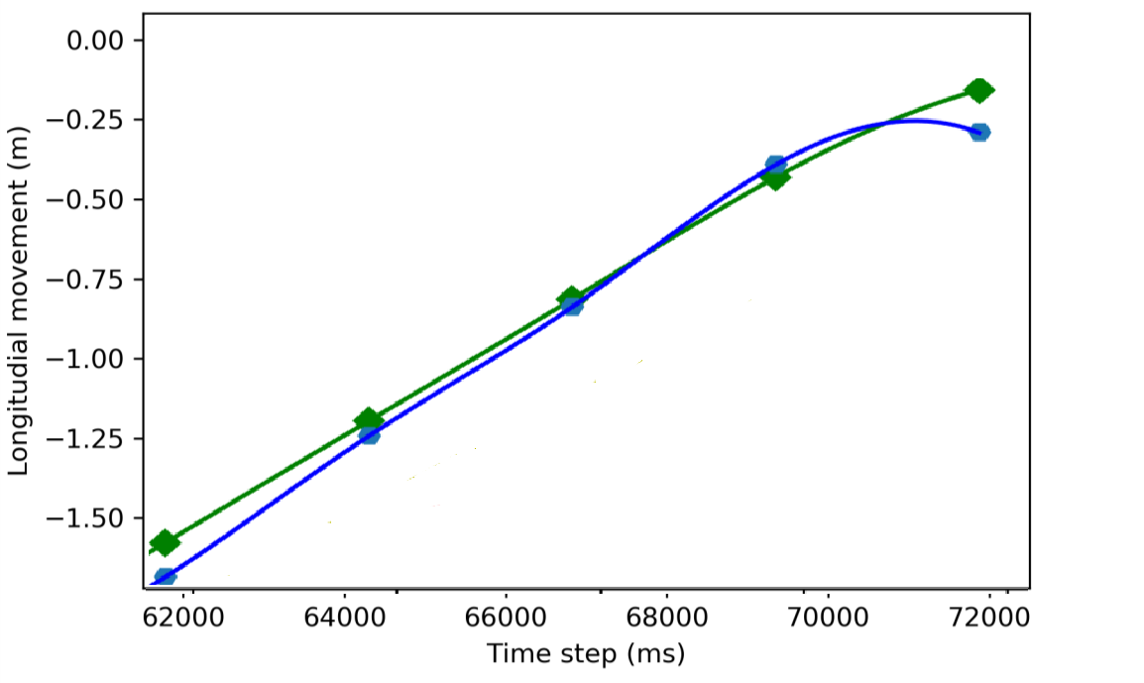
CNN
DNN
Figure 10: Accuracy comparison between CNN and DNN

A dataset of images is obtained after testing and training the data from the first trial of our self-driving vehicle. The dataset consisted of videos and images with similar structure to the tracks used by us. A test data is used to evaluate the accuracy of the model. A new curvature of road (black sheet) is introduced for test case. After several testing terms, we noticed that the accuracy increased and that with every try-out, the car started to make more precise turns. The car drove effortlessly and dogged the obstructions in the lane with apt precision.

Discussion
Many proposed autonomous vehicle benefits, including congestion and emission reductions, require platooning: multiple electrically connected vehicles travelling close together at relatively high speeds, preferably lead by a large truck. This requires dedicated highway lanes in figure 11. Fuel consumption by vehicle is shown according to their size along with the graph which is based on the measurements performed on a demonstrator system.

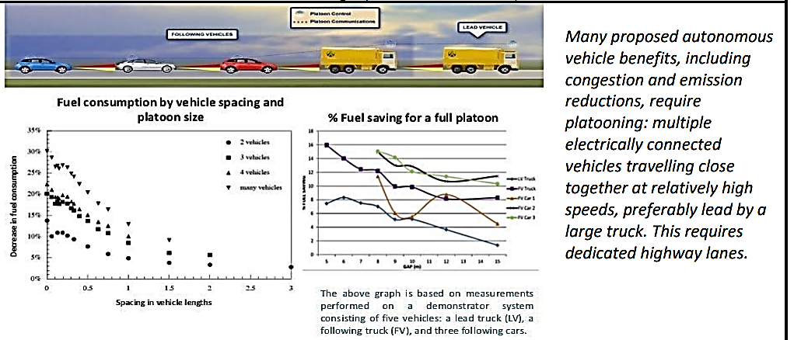
Figure 11: Pollution emissions of autonomous vehicle

Some researchers think that the future of vehicles is electric- energy saving vehicles in figure 12. Today we have a heavy reliance on Fossil fuels for running our vehicles and these fuels are non-renewable hence, should be used judiciously. By consuming fossil fuels, we are not only exhausting our resources but also adding to the air pollution.
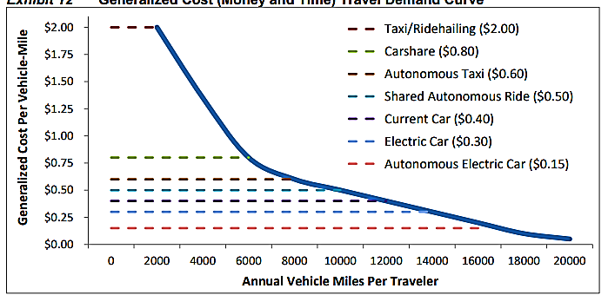
Figure 12: Generalized Cost (Money and Time) Travel Demand Curve

Autonomous vehicles are one of many factors affecting future transport demands. Whereas, with electric vehicles, we will have a one less problem to worry about, shown in figure 13.

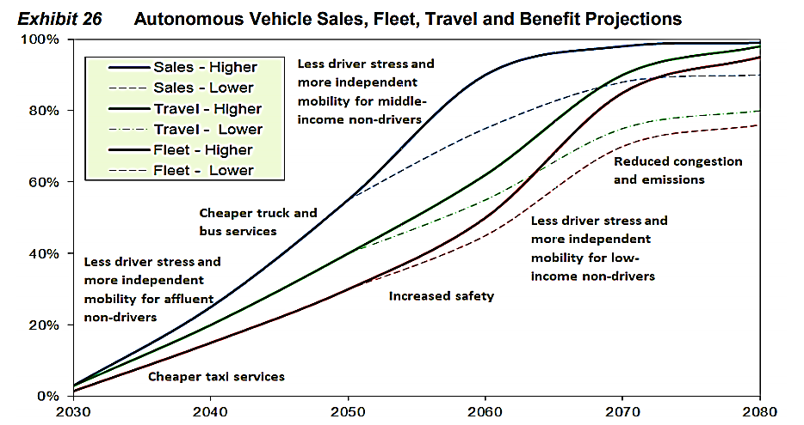
Figure 13: Smart vehicle – Sales-Fleet-Travel-Benefit Projections

But thinking that vehicles running on electricity will not cause any harm is a hoax as the automobile running on current produces particulate discharge from using breaks and wear and tear of tires. This emission is also hazardous

Conclusion and Future Perspective
Learning approach in building a self-driving vehicle from beginning to end is an effective alternative to the traditional one. The car learned driving mannerisms and could detect road without the need for explicit labels, it proved to give viable results in a limited time frame which is also very cost- effective. The proposed model can be developed for industry point of view and should be viewed as independent of the vehicle like a CNG kit as the vision is to develop a setup that can be incorporated into any vehicle given that its acceleration and direction can be controlled.

A future analysis indicates that there are still about 25 years left for autonomous vehicles to take up half the automobile market and probably 40 years to be produced with autonomous fleet. In coming years, we might see the trend of discarding vehicles which are not smart and self-driving. It is obvious that at first autonomous vehicles will be very costly, and only the affluent will be able to take the luxury of using them. Nevertheless, unless autonomous vehicles become a common thing, they will not be affordable to moderate-income people/organizations.

References
- Jiakai Zhang (2019) End-to-end Learning for Autonomous Driving. Dissertation, New York University
- Udacity, Inc. Self-Driving Car Simulator. https://github.com/udacity/self-driving-car-sim.
Accessed on 5 Feb 2019
- Zheng Wang (2018) Self Driving RC Car.https://zhengludwig.wordpress.com/projects/self- driving-rc-car/. Accessed 22 Jan 2019
- Desai, S. and Desai, S., 2017. Smart vehicle automation. Int. J. Comput. Sci. Mobile Comput, 6(9).
- Hussain, R. and Zeadally, S., 2018. Autonomous cars: Research results, issues, and future challenges. IEEE Communications Surveys & Tutorials, 21(2), pp.1275-1313.
- Rajasekhar, M.V. and Jaswal, A.K., 2015, August. Autonomous vehicles: The future of automobiles. In 2015 IEEE International Transportation Electrification Conference (ITEC) (pp. 1-6). IEEE.
- Rosenzweig, J. and Bartl, M., 2015. A review and analysis of literature on autonomous driving. E- Journal Making-of Innovation, pp.1-57.
- Bojarski, M., Del Testa, D., Dworakowski, D., Firner, B., Flepp, B., Goyal, P., Jackel, L.D., Monfort, M., Muller, U., Zhang, J. and Zhang, X., 2016. End to end learning for self-driving cars. arXiv preprint arXiv:1604.07316.
- Jackel, L.D., Krotkov, E., Perschbacher, M., Pippine, J. and Sullivan, C., 2006. The DARPA LAGR program: Goals, challenges, methodology, and phase I results. Journal of Field robotics, 23(11‐12), pp.945-973.
- Lecun, Y., Cosatto, E., Ben, J., Muller, U. and Flepp, B., 2004. Dave: Autonomous off-road vehicle control using end-to-end learning. Courant Institute/CBLL, http://www. cs. nyu. edu/yann/research/dave/index. html, Tech. Rep. DARPA-IPTO Final Report.
- Podpora, M., Korbas, G.P. and Kawala-Janik, A., 2014. YUV vs RGB-Choosing a Color Space for Human-Machine Interaction. FedCSIS Position Papers, 18, pp.29-34.
- Pan, Y., Cheng, C.A., Saigol, K., Lee, K., Yan, X., Theodorou, E. and Boots, B., 2017. Agile autonomous driving using end-to-end deep imitation learning. arXiv preprint arXiv:1709.07174.
- M. Bojarski, D. Del Testa, D. Dworakowski, B. Firner, B. Flepp, P. Goyal, and X. Zhang, “End to end learning for self-driving cars”, arXiv preprint arXiv:1604.07316, 2016.
- A. Gurghian, T. Koduri, S. V. Bailur, K. J. Carey and V. N. Murali, "DeepLanes: End-To-End Lane Position Estimation Using Deep Neural Networks," 2016 IEEE Conference on Computer Vision and Pattern Recognition Workshops (CVPRW), Las Vegas, NV, 2016, pp. 38-45.
- J. Huang et al., "Speed/Accuracy Trade-Offs for Modern Convolutional Object Detectors," 2017 IEEE Conference on Computer Vision and Pattern Recognition (CVPR), Honolulu, HI, 2017, pp. 3296-3297.
- R. K. C. Billones, A. A. Bandala, E. Sybingco, L. A. G. Lim, A. D. Fillone and E. P. Dadios, "Vehicle detection and tracking using corner feature points and artificial neural networks for a vision-based contactless apprehension system," 2017 Computing Conference, London, 2017, pp. 688-691.
- LeCun, Y., Cosatto, E., Ben, J., Muller, U., & Flepp, B. (2004). DAVE: Autonomous off-road vehicle control using end-to-end learning. Technical Report DARPA-IPTO Final Report, Courant Institute/CBLL, http://www.cs.nyu.edu/yann/research/dave/index.html
- D.A. Pomerleau, (1989). Alvinn: An autonomous land vehicle in a neural network. In Advances in neural information processing systems (pp. 305-313).
- H. A. Rowley, S. Baluja, and T. Kanade. “Neural network based face detection”, IEEE Trans. Pattern Anal. Mach. Intell., 20(1):23-38, 1998.
- A. Sharifara, M. S. Mohd Rahim, Y. Anisi, "A general review of human face detection including a study of neural networks and Haar feature-based cascade classifier in face detection," Biometrics and Security Technologies (ISBAST) 2014 International Symposium on, pp. 73-78, 2014.
- S. I. Baykal, D. Bulut and O. K. Sahingoz, "Comparing deep learning performance on Big Data by using CPUs and GPUs," 2018 Electric Electronics, Computer Science, Biomedical Engineering’s' Meeting (EBBT), Istanbul.
- Y. J. Mo, J. Kim, J. K. Kim, A. Mohaisen, and W. Lee, “Performance of deep learning computation with TensorFlow software library in GPU-capable multi-core computing platforms”, In Ubiquitous and Future Networks (ICUFN), 2017 Ninth International Conference on , 2017, July, pp. 240-242.
- T. Gong, T. Fan, J. Guo, and Z. Cai, “GPU-based parallel optimization of immune convolutional neural network and embedded 2018 6th International Conference on Control Engineering & Information Technology (CEIT), 25-27 October 2018, Istanbul, Turkey system. Engineering Applications of Artificial Intelligence”, 62, 2017, pp. 384-395.
- Parashar A., Parashar A. (2020) IoT-Based Cloud-Enabled Smart Electricity Management System. In: Somani A., Shekhawat R., Mundra A., Srivastava S., Verma V. (eds) Smart Systems and IoT: Innovations in Computing. Smart Innovation, Systems and Technologies, vol 141. Springer, Singapore. https://doi.org/10.1007/978-981-13-8406-6_71.
- Carlini, N., and D. Wagner. Towards Evaluating the Robustness of Neural Networks. Proceedings - IEEE Symposium on Security and Privacy, 2017, pp. 39–57. https://doi.org/10.1109/SP.2017.49.
- G. Bresson, Z. Alsayed, L. Yu and S. Glaser, "Simultaneous Localization and Mapping: A Survey of Current Trends in Autonomous Driving," in IEEE Transactions on Intelligent Vehicles, vol. 2, no. 3, pp. 194-220, Sept. 2017.
- S. Choudhury, S. P. Chattopadhyay and T. K. Hazra, "Vehicle detection and counting using haar feature-based classifier," 2017 8th Annual Industrial Automation and Electromechanical Engineering Conference (IEMECON), Bangkok, 2017, pp. 106-109.
- Tefft, B. C. The Prevalence of Motor Vehicle Crashes Involving Road Debris, United States, 2011- 2014. AAA Foundation for Traffic Safety, No. 24, 2016, pp. 1–10.
- Bertozzi, M., A. Broggi, and A. Fascioli. Vision-Based Intelligent Vehicles: State of the Art and Perspectives. Robotics and Autonomous Systems, Vol. 32, No. 1, 2000, pp. 1–16. https://doi.org/10.1016/S0921-8890(99)00125-6.
- Dagan, E., O. Mano, G. P. Stein, and A. Shashua. Forward Collision Warning with a Single Camera. Dagan, E., O. Mano, G. P. Stein, and A. Shashua. Forward Collision Warning with a Single Camera IEEE Intelligent Vehicles Symposium, 2004, 2004, pp. 37–42. https://doi.org/10.1109/IVS.2004.1336352.
- Tatarek, T., J. Kronenberger, and U. Handmann. Functionality, Advantages and Limits of the Tesla Autopilot.
- Krizhevsky, A., I. Sutskever, and G. E. Hinton. ImageNet Classification with Deep Convolutional Neural Networks. Advances In Neural Information Processing Systems, 2012, pp. 1–9. https://doi.org/http://dx.doi.org/10.1016/j.protcy.2014.09.007.
- Yang, Z., Y. Zhang, J. Yu, J. Cai, and J. Luo. End-to-End Multi-Modal Multi-Task Vehicle Control for Self-Driving Cars with Visual Perception. 2018.
- Bojarski, M., D. Del Testa, D. Dworakowski, B. Firner, B. Flepp, P. Goyal, L. D. Jackel, M. Monfort, U. Muller, J. Zhang, X. Zhang, J. Zhao, and K. Zieba. End to End Learning for Self-Driving Cars. 2016, pp. 1–9.
- Bhavsar, P., P. Das, M. Paugh, K. Dey, and M. Chowdhury. Risk Analysis of Autonomous Vehicles in Mixed Traffic Streams. Transportation Research Record: Journal of the Transportation Research Board, Vol. 2625, No. 1, 2017, pp. 51–61. https://doi.org/10.3141/2625-06.
- Yao, J., S. Fidler, and R. Urtasun. Describing the Scene as a Whole: Joint Object Detection, Scene Classification and Semantic Segmentation. Proceedings of the IEEE Computer Society Conference on Computer Vision and Pattern Recognition, 2012, pp. 702–709. https://doi.org/10.1109/CVPR.2012.6247739.
- Pomerleau, D. a. Alvinn: An Autonomous Land Vehicle in a Neural Network. Advances in Neural Information Processing Systems 1, 1989, pp. 305–313.
- Zhang, M., Y. Zhang, L. Zhang, C. Liu, and S. Khurshid. DeepRoad: GAN-Based Metamorphic Testing and Input Validation Framework for Autonomous Driving Systems. 2018, pp. 132–142. https://doi.org/10.1145/3238147.3238187.
- Beaufays, F., H. Sak, and A. Senior. Long Short-Term Memory Recurrent Neural Network Architectures for Large Scale Acoustic Modeling Has. Interspeech, No. September, 2014, pp. 338–342. https://doi.org/arXiv:1402.1128.

